**Task Description#2**

* Compare Gemini and Copilot outputs for a palindrome check function.

**Expected Output#2**

* Side-by-side comparison and observations

PROMPT :

Write a python function to check whether the given number is palindrome or

not and read the input from the user..

GEMINI :

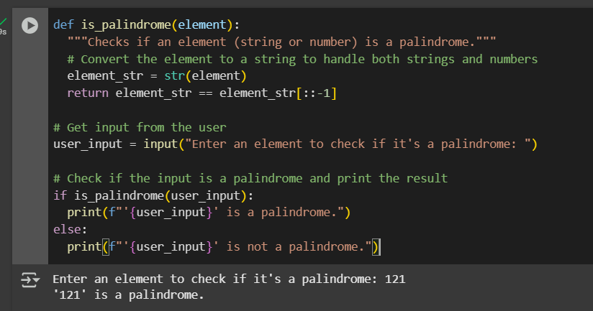

COPILOT :

